Chapter 18, Solution 26.

(a) 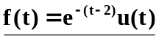

(b) 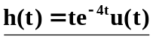

(c) If 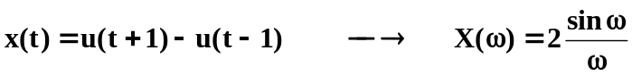

By using duality property,

